Time gpt

Introduction:

Gallium, indium, and cobalt are pivotal in advancing clean energy technologies due to their unique properties and applications:

**Gallium**: Utilized in gallium-arsenide (GaAs) and copper-indium-gallium-diselenide (CIGS) thin-film solar cells, gallium enhances the efficiency of photovoltaic systems. Its role in semiconductors is crucial for high-efficiency solar panels. <https://www.usgs.gov/media/images/critical-mineral-commodities-renewable-energy>

**Indium**: Indium is a key component in CIGS thin-film solar cells, contributing to their efficiency and performance. Additionally, indium-tin-oxide (ITO) is used in transparent conductive coatings for touch screens and photovoltaic cells.

<https://www.usgs.gov/media/images/critical-mineral-commodities-renewable-energy>

**Cobalt**: Cobalt is essential in lithium-ion batteries, serving as a component in cathode materials. Its inclusion improves energy density and battery life, making it vital for electric vehicles (EVs) and energy storage systems.

<https://www.usgs.gov/media/images/critical-mineral-commodities-renewable-energy>

**Relationship Between Exogenous Variables and Demand for These Elements**:

* **Price per Unit of Each Element**: The cost of gallium, indium, and cobalt directly influences their demand. Higher prices can lead to increased production costs for clean energy technologies, potentially reducing demand. Conversely, lower prices may encourage adoption and boost demand.
* **Electric Vehicle (EV) Market Growth**: The expansion of the EV market significantly impacts cobalt demand, as lithium-ion batteries in EVs rely on cobalt-containing cathodes. A surge in EV production escalates the need for cobalt.

<https://ourworldindata.org/countries-critical-minerals-needed-energy-transition>

**Lithium-Ion Battery Price**: Decreasing lithium-ion battery prices can stimulate demand for EVs and energy storage solutions, thereby increasing the demand for cobalt. Affordable batteries make clean energy technologies more accessible, driving up the need for critical materials.

TimeGPT is a foundational model for time series forecasting, leveraging transformer-based architectures to predict future values across various domains without additional training. It processes historical data and exogenous variables to generate accurate forecasts, accommodating diverse input sizes and forecasting horizons. TimeGPT's adaptability and efficiency make it a valuable tool for anticipating market dynamics in critical materials

Methodology :

https://www.datacamp.com/tutorial/time-series-forecasting-with-time-gpt

[TimeGPT-1](https://arxiv.org/abs/2310.03589) is a Transformer-based time series model with [self-attention mechanisms](https://www.datacamp.com/blog/attention-mechanism-in-llms-intuition) that you can access using the Nixtla API. It is the first foundational model for time series datasets that is fairly accurate on unseen data. All you have to do is fine-tune it on your dataset, and within a few seconds, it will provide state-of-the-art performance.

The TimeGPT architecture consists of an encoder-decoder structure with multiple layers, each equipped with residual connections and layer normalization. The output layer is linear and maps the decoder's output to the forecasting window's dimension.

It was trained on the largest collection of publicly available time series data, meaning it can forecast unseen datasets without requiring retraining. To produce a forecast, TimeGPT takes a window of previous values and adds a local positional encoder to enhance the input.

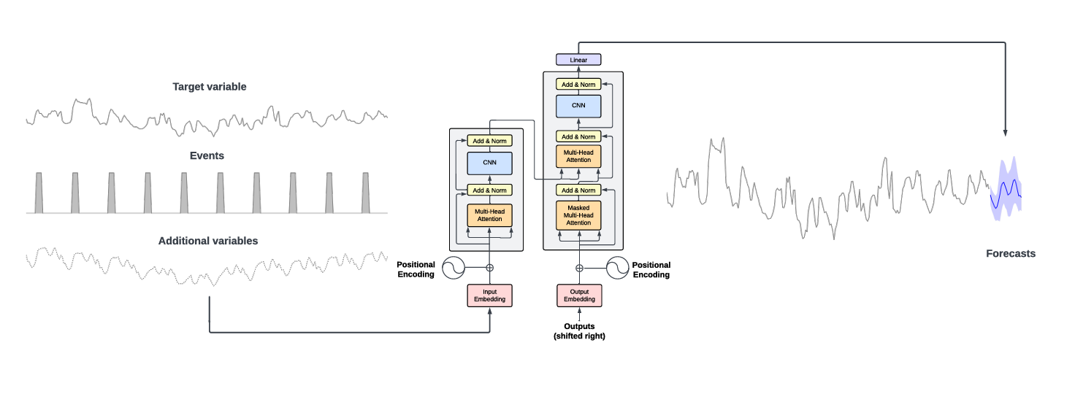

The TimeGPT model outperforms established statistical, machine learning, and deep learning methods, showcasing superior zero-shot inference performance, efficiency, and simplicity. As demonstrated in the benchmark below, TimeGPT excels across various machine learning metrics even without any feature engineering.{ <https://arxiv.org/pdf/2310.03589>}

Time gpt documentation: